Assessment Schedule – 2016
Mathematics and Statistics: Investigate relationships between tables, equations and graphs (91028)

Evidence Statement
One | Expected coverage | Achievement (u) | Merit (r) | Excellence (t)
(a)(i) | $50 | Correct value.
(ii) | Lines joining (5,65) to (6,65) – open circle  and (6,80) to (7,80) – open circle. | Correct step functions without open circle or one correct step. |  | Correct step functions with open circles.
(iii) | Gradient (slope) of the graph of line joining (0,0) to (6,80).  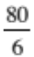 = $13.33 | Accept 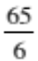. | Correct solution calculated.
(iv) | y = 10x OR (P = 10t) | Correct equation.
(v) | Let t be time for baby sitting  If  - t < 5.5 hours, Talia is the cheapest  - t > 5.5, Sasha is the cheapest  - t < 3, Talia is cheapest  - 3 < t < 5.5 Talia is the cheapest  - Matt is never the cheapest. | 1 region correct. | 2 regions correct. | 3 correct descriptions.
(b)(i) | y = 2x² + 5x – 3  OR y = 2(x – 0.5)(x + 3)  OR y = 2(x + 1.25)² – 6.125  OR y = (2x – 1)(x + 3) | 1 term incorrect.  OR equivalent. | Correct equation.
(ii) | y = 2(x –a)² + 5(x – a) – 3 + b  y = 2(x² – 2ax + a²) + 5x – 5a – 3 + b  y = 2x² – 4ax + 2a² + 5x – 5a – 3 + b  y = 2x² + (5 – 4a)x + 2a² – 5a – 3 + b  y = 2(x – (–1.25 + a)² – 6.125 + b  y = 2(x + 1.25 – a)² – 6.125 + b  x value of turning point is – 1.25 + a  turning point is (–1.25 + a,–6.125 + b) | Just a or just b. | Initial equation. | x value of turning point or coordinates of turning point.
 | N1: one question attempted  N2: 1u | A3: 2 of u or 1 of r  A4: 3 of u or  1 of r and 1 of u | M5: 2 of r  M6: 3 of r | E7: 1 of t  E8: 2 of t

TWO | Expected coverage | Achievement (u) | Merit (r) | Excellence (t)
(a)(i) | Graph of A = –x² + 40x  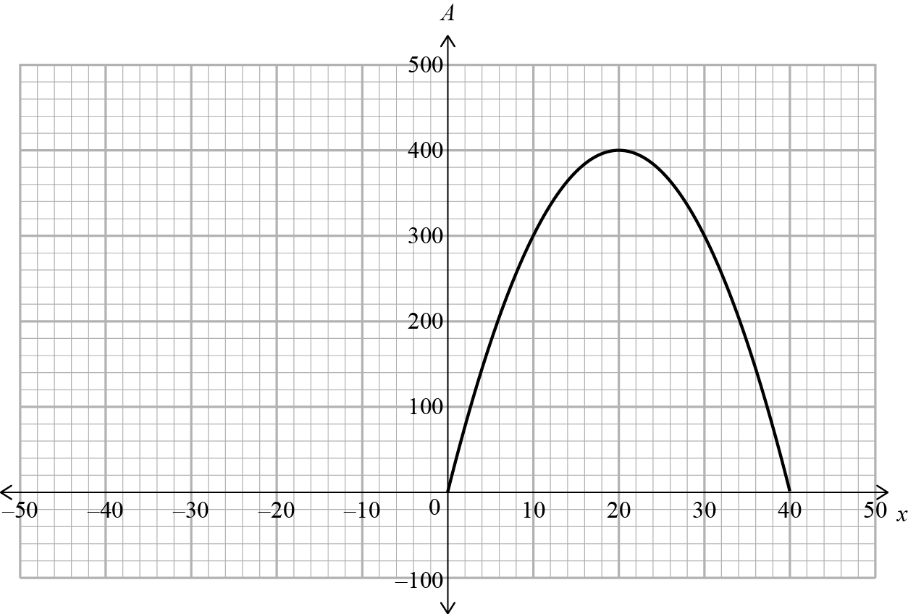 | Correct graph without restriction to the first quadrant. | Accurate graph in the first quarter.
(ii) | Maximum area is 400 (when x = 20). | Correct response.
(iii) | 0 < x < 10 and 30 < x < 40. | 30 < x < 10  OR 10 > x > 30 | Indicates x < 10  AND x > 30. | 0 < x < 10  AND 30 < x < 40
(iv) | x value = 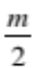  Area = 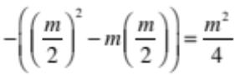 | 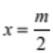 | Correct simplified solution.
(b)(i) | 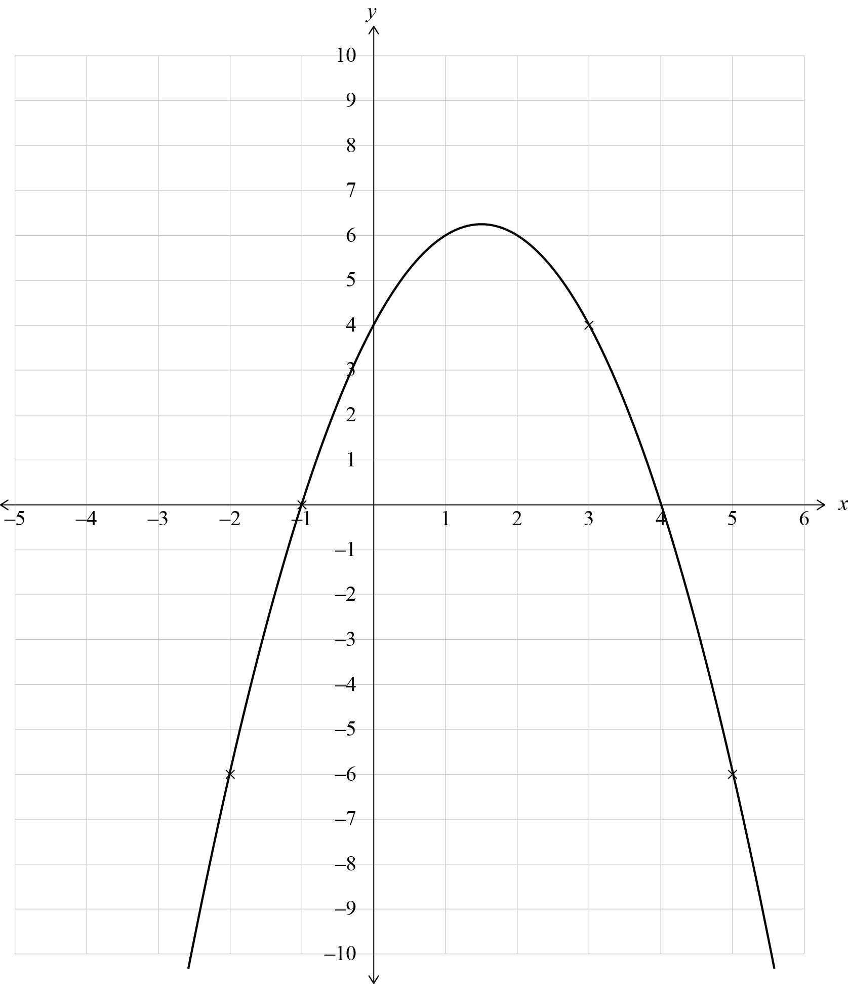  - x-intercepts (–1,0) and (4,0)  - y-intercept (0,4)  - Max coordinates (1.5, 6.25) accept y between 6 < x ≤ 7 (on graph). | Any TWO of intercepts or vertex and ONE feature of graph correct.  Symmetrical parabola. | Any THREE of intercepts and vertex and one error on graph.  (Does not have to be coordinates.)  Symmetrical parabola. | Totally correct, giving coordinates of intercepts and vertex and correct graph.  Symmetrical parabola.
(ii) | y = –x² + 3x + 4  OR y = –(x + 1)(x – 4) |  | Correct equation.
 | N1: one question attempted  N2: 1u | A3: 2 of u or 1 of r  A4: 3 of u or 1 of r and 1 of u | M5: 2 of r  M6: 3 of r | E7: 1 of t  E8: 2 of t

THREE | Expected coverage | Achievement (u) | Merit (r) | Excellence (t)
(a)(i) | y = 2^{x – 1} or equivalent. | One minor error | Correct equation.
(ii) | y = 2^{–x – 1} | One minor error. |  | Correct equation.
(b)(i) |  | At least two months correct. | Table correctly completed.
  Month (n) | Approximate number of people visiting park this month (P)
  1 | 4000
  2 | 4000
  3 | 4000
  4 | 3400
  5 | 2890
  6 | 2457
  7 | 2088
  8 | 1775
  9 | 1509
  10 | 1282
  11 | 1090
  12 | 926
(ii) | 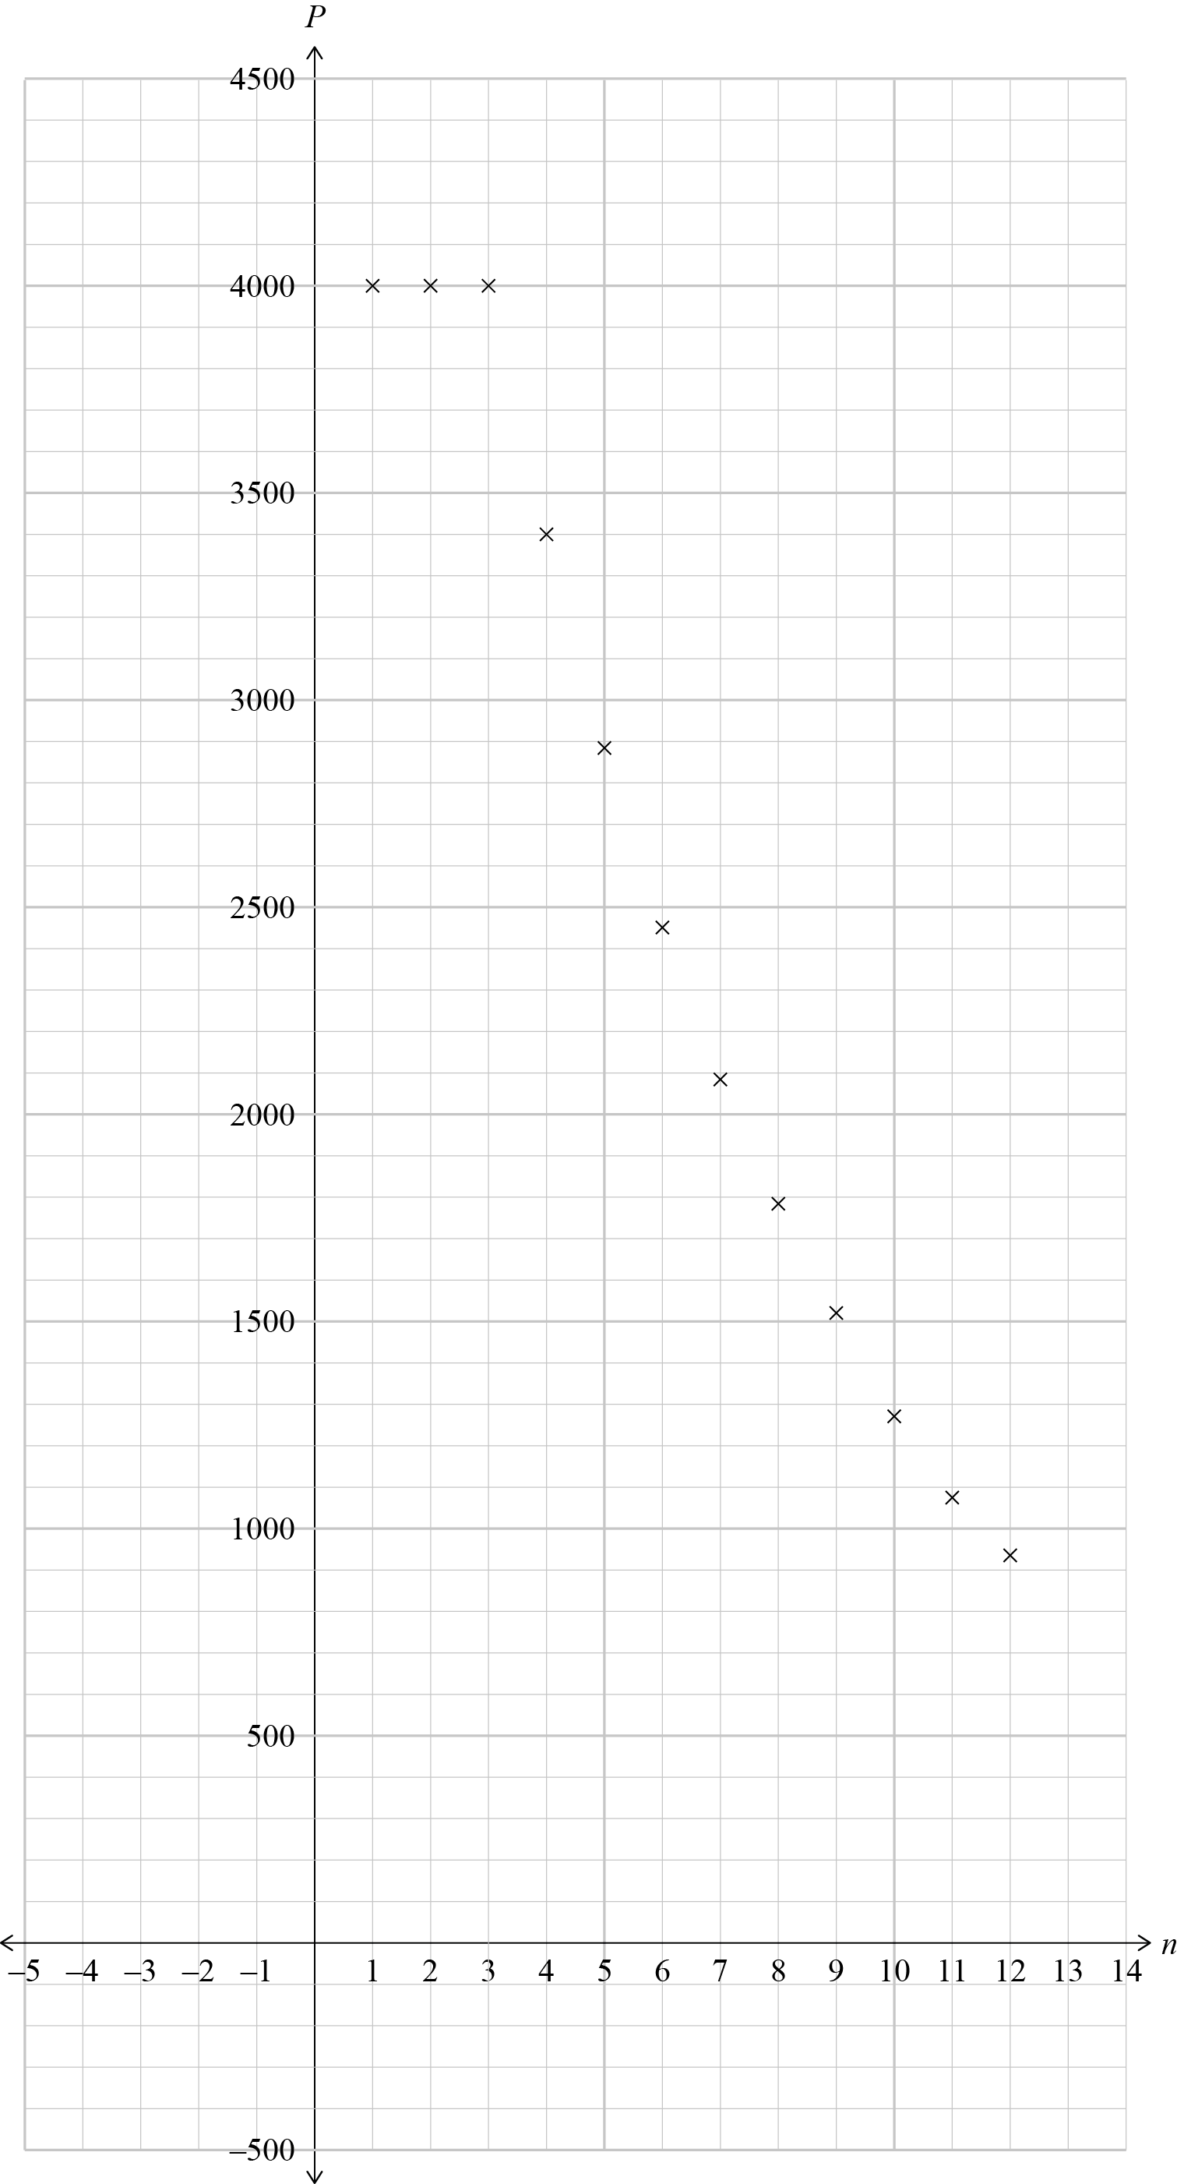  4000 for first 3 months and then from table. | At least 5 points consistent. | Consistent graph drawn as discrete or continuous.  Allow one point incorrect.
(iii) | Solution found by finding the x-coordinate of where the graph of P = 2000 intersects the graph of  P = 4000 × 0.85^{n}  OR from table  OR by calculation  2000 = 4000 × 0.85^{x}  x = 4.26  Number of months = 7.26  At the end of the 8th month, there will be fewer than 2000 visitors. | Partial description and 7th month.  OR  Closed for 5 months.  4 only (CAO) | Stated closed for 4 months with correct
(iv) | 2000 = A × 0.85^{(10 – 3)}  A = 6238.7  The required number is at least 6239. |  | Demonstrated use of 0.85 and consistent with graph. | Required number of people found.
 | N1: table in b correct  N2: 1u | A3: 2 of u or 1 of r  A4: 3 of u or 1 of r and 1 of u | M5: 2 of r  M6: 3 of r | E7: 1 of t  E8: 2 of t

Cut Scores
Not Achieved | Achievement | Achievement with Merit | Achievement with Excellence
0 – 6 | 7 – 13 | 14 – 18 | 19 – 24

